SOLUTIONS

1. (a)

(b)

2. (a) -1/error

(b)

(c)

(d) 5th term= ⁸C₄ (2x)⁴ (-y)⁴ = 70 x 16x⁴ x y⁴ = 1120 x⁴ y⁴

3. (a) (i) 32, 16, 8, 4, -1/error
(ii) 20, 17, 14, 11

(b) (i) T₁= 150 – 4x1 =146
T₂= 150 – 4x2 =142
T₃= 150 – 4x3 =138
(ii) T_{n+1}= T_{n} – 4, T₁= 146

4. (a) 0.57 (b) 0.6

SECTION 2: CALCULATOR ASSUMED

5.
Solution
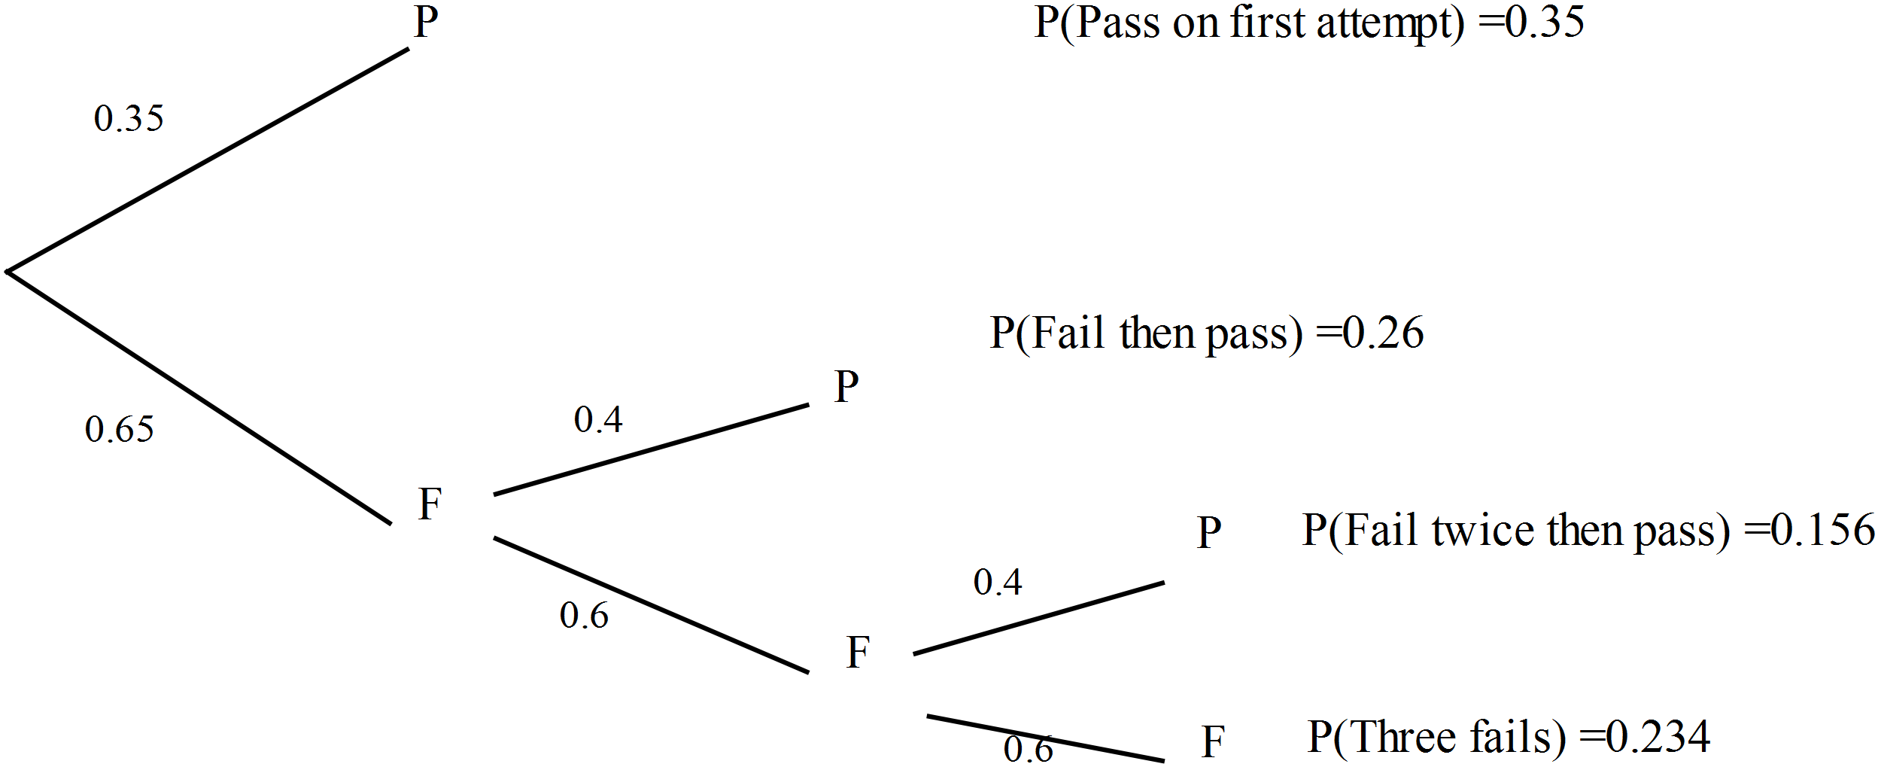

Marking key/mathematical behaviours | Marks
- Provides a tree diagram where the branches stop after a P (pass)  - Has the correct number of attempts  - Shows probabilities of pass and fail  - Determines the outcomes and associated probabilities | 1  1  1  1

(b)
Solution
P(pass in two or less attempts) = 0.35 + 0.26 = 0.61
Marking key/mathematical behaviours | Marks
- Provides the two possible outcomes to pass  - Adds the two probabilities | 1  1

(c)
Solution
P(pass in 3 or less attempts/not passed on first attempt)
$$\frac{0.26+0.156}{0.26+0.156+0.234 }=0.64$$

Marking key/mathematical behaviours | Marks
- Displays the correct outcomes/probabilities on the numerator  - Displays the correct outcomes/probabilities on the denominator  - Calculates the correct answer | 1  1  1

(d)
Solution
Which approaches zero. Very small probability of continual failure.
Marking key/mathematical behaviours | Marks
- Writes out the probability of never passing  Realises the answer approaches 0 | 1  1

6. (i) 1/30 (ii) 3/10
7. (a) (i)

(ii)

(iii)

(b)

(c)

(d) S₁= 10 x4 -10 = 30
S₂= 10 x4² -10 = 150

T₁= 30
T₂ = 150 -30 = 120 Hence r =120/30 = 4
8
Solution
.
The events and are independent.
Marking key/mathematical behaviours | Marks
- Uses independence law  - Uses addition law  - Evaluates P(T) | 1  1  1

